THE REMOVAL, CLEANING AND RESEATING OF THE SEGO BREWER
TEL: 01246 252832
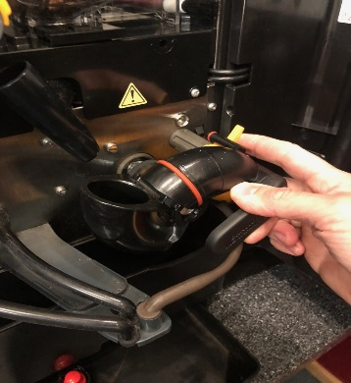
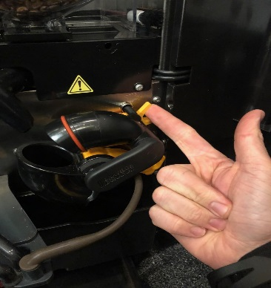
1)REMOVE THE TOP PART OF THE BREWER

2) REMOVE LOWER PART OF BREWER,
CLEAN BOTH UPPER AND LOWER PART OF BREWER WITH HOT WATER
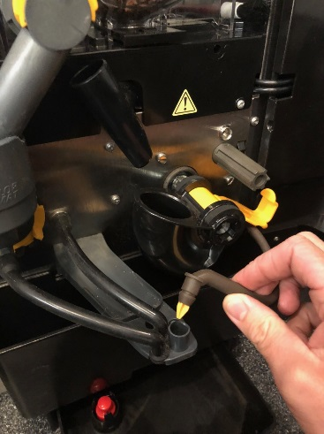
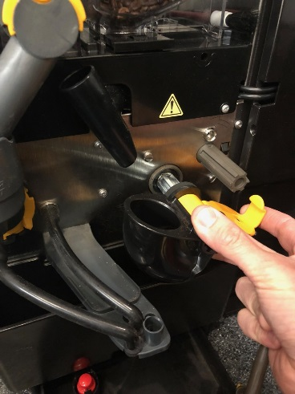
(NOT SOAPY OR CLEANING PRODUCT)

3) PLEASE ENSURE BREWER LOCKING CLIP IS IN THE CORRECT PLACE AS SHOWN BELOW WHEN RE INSTALLING THE BREWER, ONCE DONE, PLACE THE UPPER PART OF THE BREWER AND CLICK INTO PLACE

